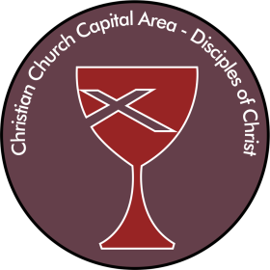
CHRISTIAN CHURCH
(Disciples of Christ)
CAPITAL AREA

2017 ANNUAL FUND – Supporting Our Churches
Please return with your contribution made out to “Christian Church Capital Area” and marked “2017 Annual Fund” in the memo line to: Christian Church Capital Area
8814 Kensington Pkwy., Ste. 208
Chevy Chase, MD 20815

If you would prefer to give online via credit card with a safe and secure site!
Please go on the web to:
https://docgeneralassembly.webconnex.com/caparea
and follow the instructions there.

Name(s): _______________________________________________________________

Address: _______________________________________________________________

Phone Number: ______________________________________ ( ) cell or ( ) home

Email: ________________________________________________________________

Church Affiliation: ______________________________________________________

Gift Amount: $________________________ ( ) one-time annual gift; ( ) monthly gift;
( ) quarterly gift

( ) I would like to receive information on how to include the Capital Area Region in my end of life bequests.

